|  |  |
| --- | --- |
| **Ex. No. 9** | **Denial of Service Attack** |
| **Date of Exercise** | 1/11/23 |

**Aim:**

The objective of this experiment is to perform Denial of Service Attack on a victim

**Description:**

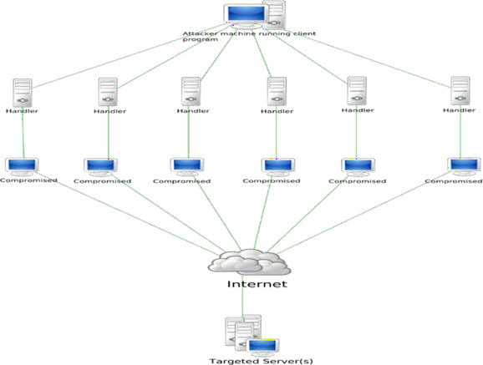In computing, a denial-of-service attack (DoS attack) is a cyber-attack in which the perpetrator seeks to make a machine or network resource unavailable to its intended users by temporarily or indefinitely disrupting services of a host connected to the Internet. Denial of service is typically accomplished by flooding the targeted machine or resource with superfluous requests in an attempt to overload systems and prevent some or all legitimate requests from being fulfilled.

**Program:**

Step 3. Set your IP address and the target IP address

**Output:**

**Result:**

Denial of Service Attack on a vulnerable machine was executed successfully using hping.